Day 12:
SQL QUERIES (Business sales Dataset)
1.Calculate revenue and profit for each order
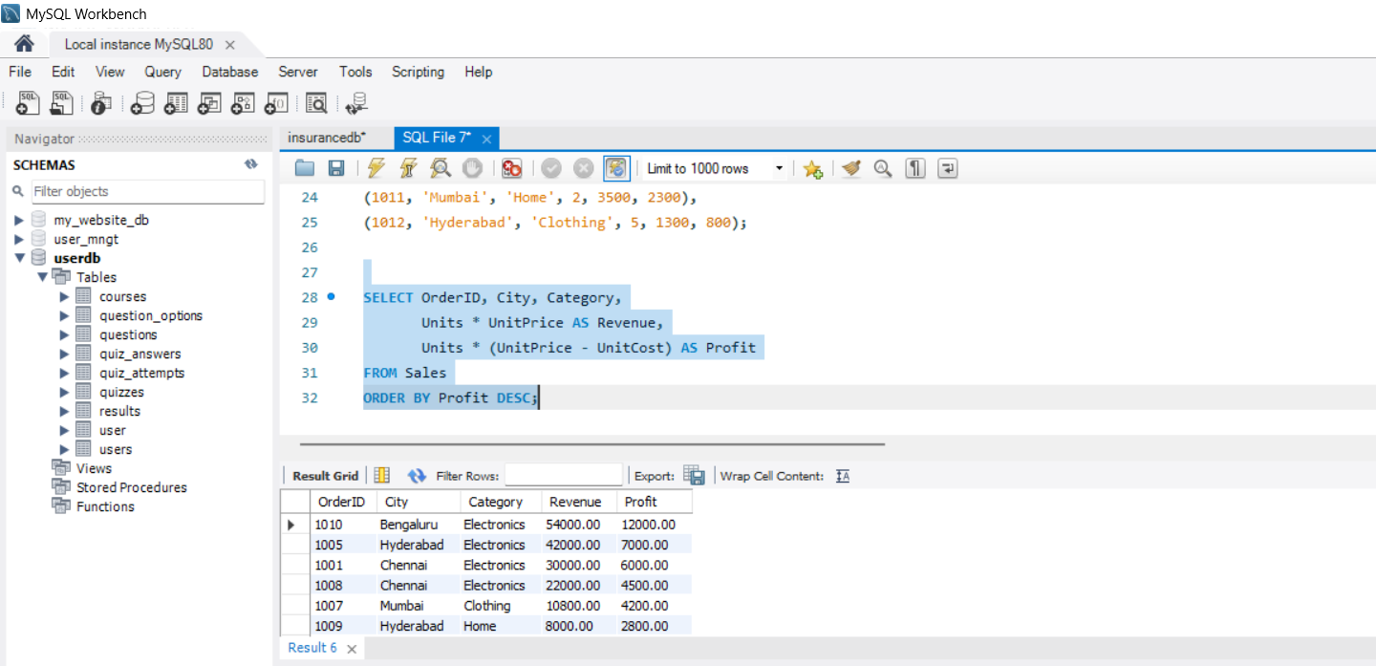

2. Calculate total revenue by product category
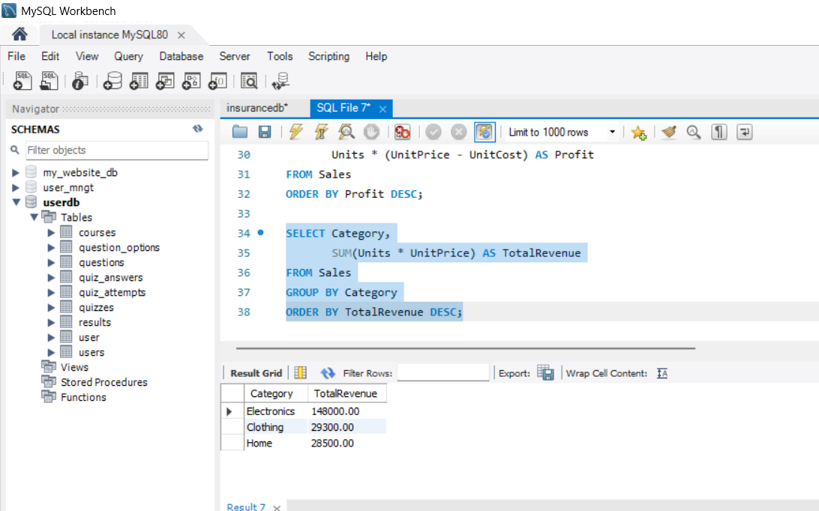

3. Filter high-revenue orders

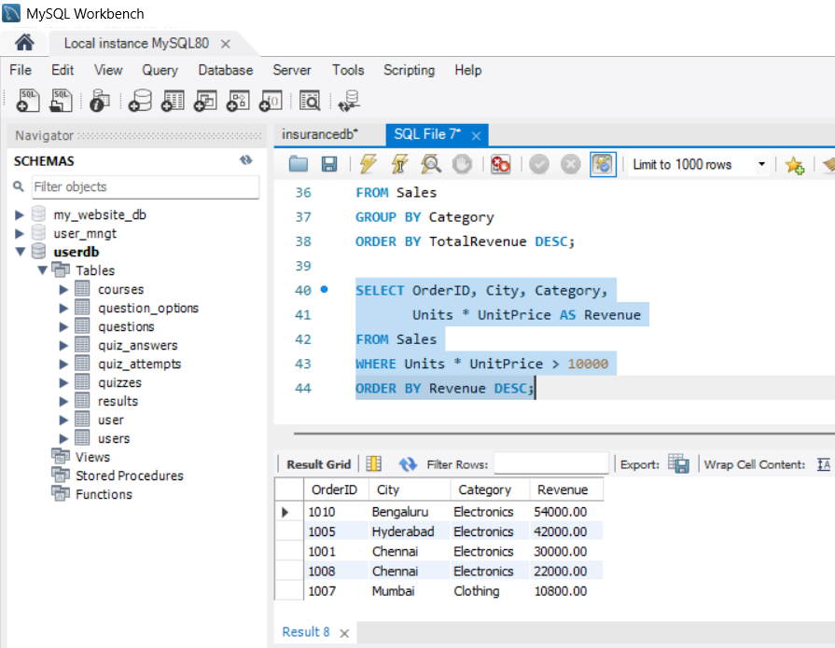

4. Find cities with total revenue above ₹30,000
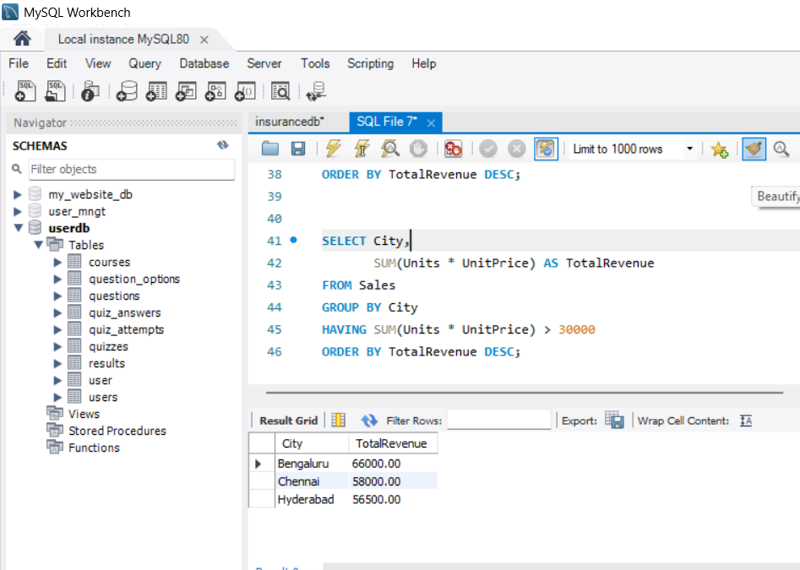
5. Find orders with above-average revenue
